1. Given a CFG given by G = (N, T, P, S) with *N* = {*S*}, *T* = {*a*, *b*}, and with the prodaction given below. Obtain the language generated L (G). (4 Point)



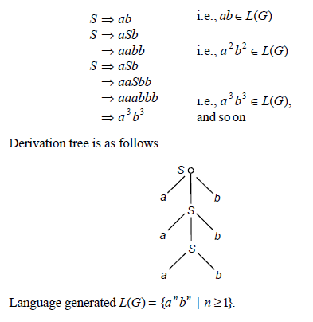

1. Consider the grammar G with production Show sequence followed is “left most derivation”, and “right most derivation”, for the string *aababbb (4 Points )*



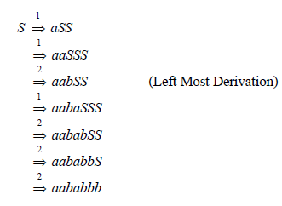

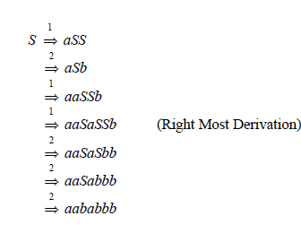

1. Eliminate unit productions from the grammar G given by productions (P).

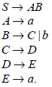

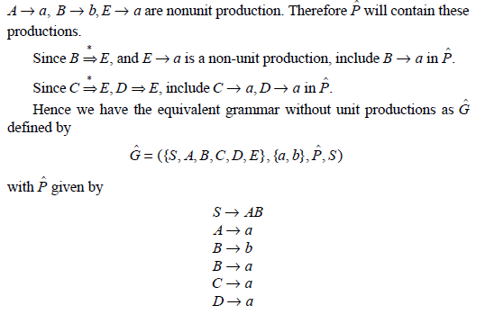

1. Obtain a grammar in Chomsky Normal Form (CNF) equivalent to the grammar G with productions P given.



